Guidance for Conducting Annual Review of Taught Programmes
Purpose and Scope of the Annual Review
- The purpose of the annual review is to bring together relevant colleagues who are responsible for the delivery and academic standards of the programme or suite of programmes, to agree priorities regarding updates and refinements to the programme and relevant actions to address any concerns. The annual review may be organised at subject, department, or school level, but the School Education Director should ensure that it is undertake for all programmes owned by the School.
- The annual taught programme review gives schools the framework to reflect on all aspects of their teaching in a timely manner. It provides the opportunity to reflect upon the effectiveness of programmes through discussion of the evidence inputs (figure 1), and to consider and plan any subsequent changes in order to improve the quality of the programmes.
- For joint honours programmes and interdisciplinary postgraduate programmes, it is the responsibility of the host school, in consultation and with the involvement of the partner school, to annually review the programme(s).
- School Education Directors are responsible for ensuring that any interdisciplinary units, which are not connected to a ‘programme’, are reviewed as part of annual programme review being held in their home school. Further information on the management of interdisciplinary units is available on the AQPO website.
What should we discuss at the Annual Review?
- The annual review is an opportunity to consider programmes and programme teams holistically in terms of identifying and sharing good practice, considering training or development needs, updating the syllabus or methods employed to deliver teaching/assessment and addressing any concerns that may have been raised via a range of quality assurance inputs in order to improve the student experience. It should review a range of evidence inputs (see figure 1) that have been gathered during the year through various ongoing quality assurance mechanisms.
- The review should discuss and agree immediate and future priorities for the programme, based on the outcomes from the discussion of the evidence inputs.
- The review must confirm that the programme specification is up to date and accurate and agree any necessary changes that may be required in light of the discussion. It is important that the programme specification and unit specifications are updated in a timely manner to ensure the central unit/programme catalogue is correct as this acts as the principal reference point for students, applicants and staff, including in the event of an appeal or complaint.
- An example agenda with a series of questions relating to the evidence inputs is provided in annex 1. The questions provided here will ensure all necessary topics are covered but the list is not exhaustive.

Figure 1: Annual Taught Programme Review EVIDENCE INPUTS (UQT – University Quality Team, PPR – Periodic Programme Revalidation, PSRB – Professional, Statutory and Regulatory Body)

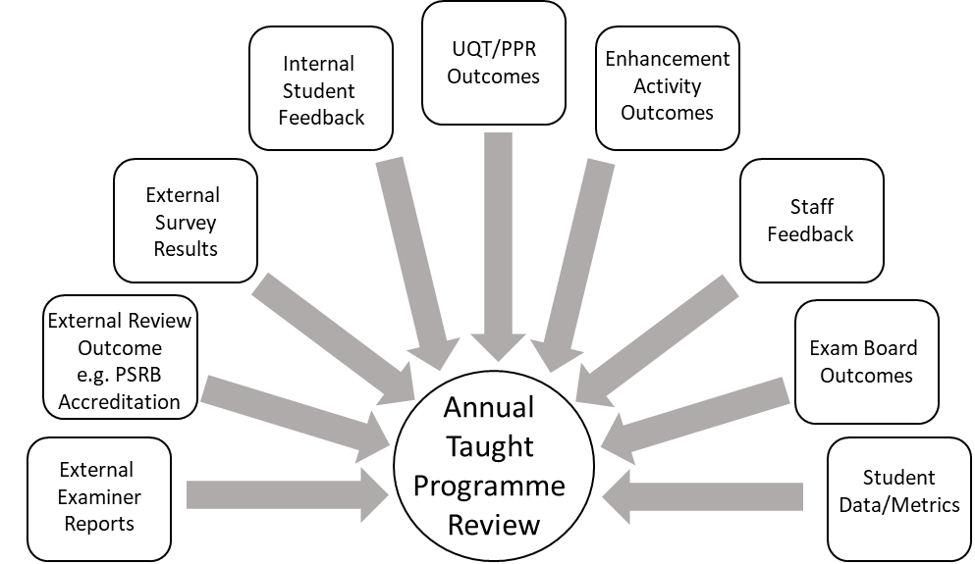

When should the Annual Review be held?
- The annual review of taught programmes should be carried out after the summer exam boards have been held so that any urgent changes to the programme can be made in time for the next academic year. The timing of the annual review should also allow sufficient time for outcomes to feed into the school’s Education Action Plan (EAP) priority setting prior to the start of the University Quality Review Team (UQT) cycle, at the end of September.
- A supplementary review of taught postgraduate programmes is held in January, once the awarding exam board has been held and external examiner reports are available, to consider whether further actions are necessary.
- Please refer to the Education Action Plan timeline for further details on how the outcomes of the annual review feeds into this.
How should the Annual Review be carried out?
- There is not a one-size-fits-all way to operate the annual taught programme review. In large multidisciplinary schools the annual reviews may take place through separate programme or discipline-level reviews or in groupings that are relevant and appropriate to the school structure.
In single discipline schools there could be one review that encompasses all taught provision.
- Suggested formats for the annual review:
  - The review could be carried out as one formal review meeting that considers all data inputs (figure 1) and agrees actions and priorities.
  - The review could take place through a series of online synchronous and asynchronous discussions at different points over the summer as relevant data becomes available for discussion, and to agree the actions and priorities.
  - The review could be carried out through a combination of online asynchronous and synchronous discussions, to discuss the data as it becomes available with in-person meetings to agree priorities and actions.
Who should be involved in the Annual Review?
- Attendees of the review meeting/s will depend upon the format, but will typically include:
  - School Education Director or equivalent (e.g. Director of Teaching and Learning)
  - PGR Directors (for taught component of PGR programme reviews if relevant)
  - Programme and Unit Leads/ year of study leads
  - Senior Tutor(s)
  - Student Administration Manager and other professional service staff as appropriate
  - Study Abroad Academic Director or Placement Coordinator
  - Student representatives (if possible)
  - External examiners – can provide helpful input into the annual review process and should be consulted where significant changes are proposed.

- For joint honours programmes the host school should invite a representative from the partner school to attend the review meeting.
- For interdisciplinary programmes, the programme Governance and Advisory Board will carry out the annual programme review. Please see the Guidance for Interdisciplinary programmes for further information.
- Where programme(s) to be reviewed are delivered through an external partnership/collaborative arrangement, participants would typically include the collaborative partner where appropriate, e.g. for joint awards. It must be ensured that appropriate representatives of all such partners have access to the supporting information that contributes to the review.
What happens with the outcomes from the Annual Review?
- The outcomes from the review may be in the form of a set of notes and actions or minutes of the relevant meetings. The outcomes inform the school’s Education Action Plan priority setting, and the departmental EAP where there is one in place.
- Any actions that have been identified to the improve the delivery of education and the student experience on the programme should be taken forward, and where relevant added to the school’s Education Action Plan.
- If programme and unit changes were agreed, these will be taken forward as proposals for change to the relevant Teaching and Learning Committee (or equivalent). If this annual review occurs during the summer period and identifies urgent changes to units, or in exceptional circumstances programmes, schools should seek to implement these in time for the next academic year. If agreed by the Faculty Education Director the fast-track programme approval process will be applied, with a deadline of 31st July, however, such late changes should only be undertaken in exceptional circumstances.
- The outcomes from the annual review should be fed-back to the student representatives.

Figure 2: Annual Programme Review OUTPUT for all programmes (EAP – Education Action Plan, SED – School Education Director, FED – Faculty Education Director).
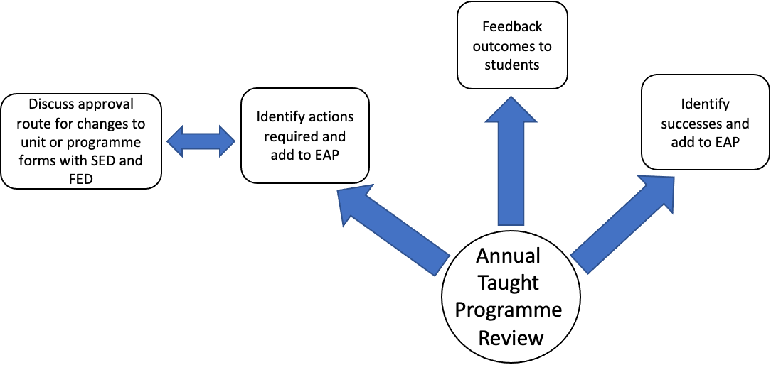

Annex 1: Agenda for Annual Programme Review
1. Welcome and apologies
2. Items for Discussion
a. Review of the successes of the previous year
- What worked well? What did students like? What did staff like? Can any of these be used elsewhere?
- Are there particularly good examples of curriculum enhancement introduced or highlighted by external examiners?
- Have staff been awarded any pedagogical grants or awards for learning and teaching?
- What successes can be highlighted on the Education Action Plan?
b. Internal Student Feedback
- How effective are processes for obtaining mid and end of unit evaluation and providing feedback to students on actions from this?
- What issues were identified for action via this feedback?
- What are the main points (negative and positive) discussed at SSLCs?
- What actions have resulted from SSLCs?
- Are any unit or programme changes required as a result of student feedback?
c. External Student Survey Results
- What is the programme(s) response rate and how does this impact on the robustness of the survey data?
- How do results compare to Institutional data? What areas are higher and what areas are lower?
- How do results compare to sector data? What areas are higher and what areas are lower?
- What actions can be identified to improve results?
- Do the free text answers provide more information that helps understanding of student concerns?
- Are any unit or programme changes required because of student survey data?
d. External Review Outcomes
- Has there been an external review of any /all of the programmes this year e.g. Professional, Statutory and Regulatory Body accreditation visit?
- Have actions been added to the EAP and has there been any progress?
e. External Examiner Reports
- What recommendations have the external examiners made and how can they be actioned?
f. UQT/PPR Recommendations
- What recommendations has the UQT/PPR made and how can they be actioned?
g. Enhancement Activity Outcomes
- Has a Curriculum Festival occurred and what actions are needed as a result?
- Has TESTA or Fast-Track TESTA occurred and what actions are needed as a result?
- If no Curriculum Enhancement Programme activity has occurred would the programme benefit from such intervention?
h. Staff Feedback
- Have any programme/unit changes that were agreed at the last review been implemented? Have they been successful?
- Are the programme and unit specifications still up to date and accurate?
- Have any incremental changes had a cumulative effect on the programme? Has the Programme Specification been revised and approved to take account of these changes?
- Are programme aims and learning outcomes still met by the mandatory units?
- Is summative and formative assessment load and methods appropriate across the programme?
- Is programme content still relevant and up-to-date?
- Is content and outcomes of year abroad/in industry satisfactory?
- Have the online materials for distance learning programmes been reviewed?
- Is the programme team still appropriate to deliver the programme, would any specific training be helpful to aid enhancement to the student experience?
- Is there feedback from educational partners? e.g Have any specific issues been identified in relation to the student experience, research environment, support and facilities arising from programmes delivered through external partnerships, professional placements or split site delivery? Is the collaboration with partners in the delivery of the programme(s) working effectively? Have any changes been made to the operation of the collaborative arrangement?

i. Exam Board Outcomes
- Are the proportion of awards and classifications consistent over time?
- Can any changes be explained? Does action need to be taken to address grade inflation/deflation?
j. Student Metrics and Data
- Are unit marks consistent over time? Is any increase/decrease explained by planned changes to the Unit or known issues with an assessment or due to specific mitigation.
- Is the number of resits for any particular Unit consistent over time? If not are changes expected?
- Is the number of resits consistent between Units? If not does action need to be taken to address unusual results?

3. Agree the priorities for the programme and what actions are required to take this forward.
- Are any programme or unit changes required? When will these be taken forward for approval?
- What are the immediate priorities for the programme?
- What are the medium-long term priorities for the programme to be taken forward over the next academic year?
- Are any new/additional resources required to complete these actions that will need to be agreed via the Integrated Planning Process (IPP)?
- Has consideration been given to alignment with
- Bristol Futures Curriculum Framework
- Skills Framework
- University/Faculty/School Education Strategy
- How will students be informed of the outcome of the review?

Template for Reporting Key Outcomes to the School Education Director for the
Education Action Planning Cycle

Programmes Covered
Date of Review
Attendees of Review
Agreed Actions
Provide details of any actions that were agreed during the annual programme review.
Concerns that need to be escalated
Provide details of any issued that should be flagged to the School Education Director, for example concerns emerging from review of student data on attainment and progression, recruitment, academic integrity, or staff resource.
Recommended programme changes that need to be taken forward in UPMS
Detail any agreed programme changes, for example assessment and teaching methods, learning outcomes or other changes to the programme or unit specifications. Provide the proposed timeframe for implementation.
Strategic Priorities
Provide details of any other strategic priorities for the programme(s), for example planning for a curriculum review or major programme change.

